ETHERLEY LANE NURSERY AND PRIMARY SCHOOL FEDERATION.

Welcome back to what has already been a very busy start to the new term! We are delighted by how well the children have settled back into school and nursery. We had a wonderful time last term after the Christmas break and our children were involved in lots of activities in school.

We are holding a free cookery class for our key stage 2 pupils with their parent/carers every Monday which is an 8 week course, the children are really enjoying this course and are always talking about what is going to be on the menu for the following week!

Year 4 took part in some Netball sessions in collaboration with King James 1 Academy. The children have loved learning new skills about the sport

Year 1 and 2 had a visit from the Zoolab as part of our science work in school. They had a chance to see a range of minibeasts and learn about them and their habitats. There was a rat, snake, tarantula and frogs that came for a visit. The children had chance to have a close look and even touch them if they wanted to.
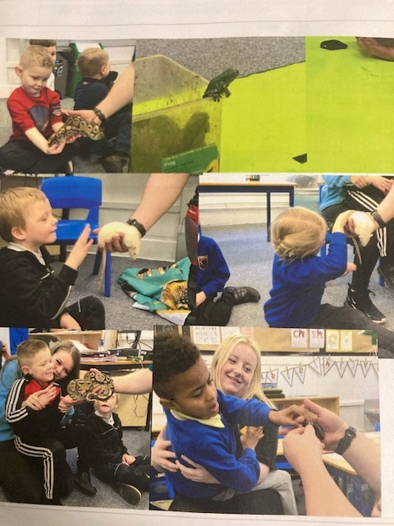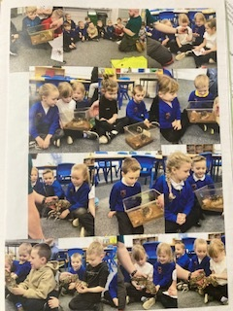

Year 3 had a school trip to Palace Green Library in Durham. They learnt about the Stone Age to Iron Age.

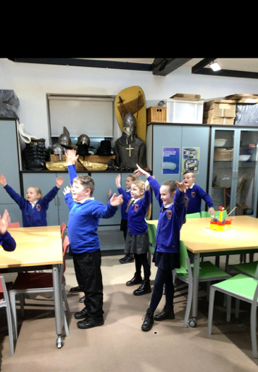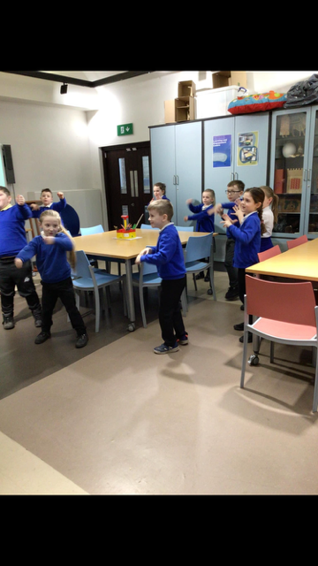

In school and nursery we learnt about Chinese New Year. We learnt it was the year of the dragon! Everyone had lots of fun making lanterns, fireworks, bunting and even made our very own dragon! The children also tried some noodles and rice.

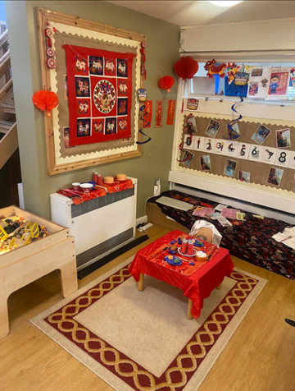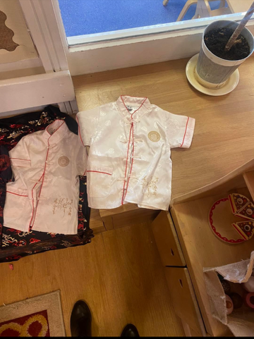

Children’s Mental Health week. The children took part in lots of activities and every child in school made a friendship bracelet. We had a delivery from Angel Trust that included resources such as books, that we can use in school for the children.

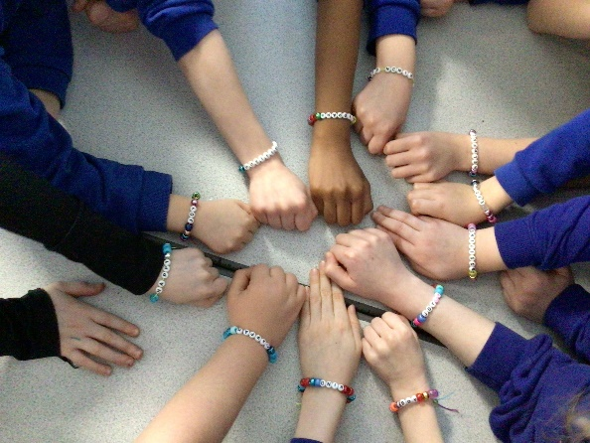

Year 3 - swim every Tuesday till Easter

Year 5 - swim every Thursday till Easter

Year 4 – attending King James every Monday till Easter to complete a DT lesson

Year 2 – Attending King James every Friday to take part in a reading session

Afterschool clubs continue this half term and will finish at Easter for the children that have been allocated a place

Monday - Cross Stitch, Karaoke,

Wednesday – Invasion games, Film club

Wednesday- Trampolining at King James Academy ( Year 5 only)

Thursday – Gardening club, Ballroom dancing,

Dates for the diary

Thursday 7th March 2024 - Whole school and Nursery – World Book day, children can come into school dressed up or in pyjamas

8th-17th March 2024 - Whole School and Nursery - British Science Week

Tuesday 12th March 2024 – Year 5 – Visit to King James as part of British Science week to take part in a topic

Thursday 14th March 2024 - Whole school - Cricket Taster Day

Week commencing -25th March 2024 – Bling your bonnet, children to decorate a bonnet in school that week
Monday 25th March 2024 – Year 3 are attending a tennis festival at Bishop Auckland College
Thursday 28th March 2024 – Whole school and Nursery break up for Easter
Monday 15th April 2024 – Whole school and Nursery return back to school
Monday 6th May 2024 – Whole School and Nursery closed
Friday 24th May 2024 – Whole school and Nursery closes for half term
Tuesday 4th June 2024 – Whole school and Nursery reopens
Friday 19th July 2024 – Whole school and Nursery closes for the summer holidays

Like always if anyone has any questions please contact the school office

