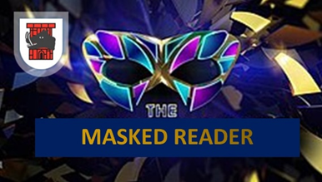
Who do you think is behind the mask?
Reader and story | Guess
- Monster- Monstersaurus
- Girl- The Fibbs

- Panda 1- There’s a Tiger in the Garden
- Alien 1- The Dinosaur that Pooped the Bed
- Mermaid- A Squash and a Squeeze

- Mrs. Black Hat- Mrs. Black Hat

- Barbie- My Pet Star

- Peas- Smelly Peter the Great Pea Eater
- Fries- Giraffes Can’t Dance

- Pony- Dream Big, Little Mole

- Teddy- There’s a Snake in My School!

- Boy- Poo at the Zoo

- Dinosaur- Dinosaurs in My School

- Bear 1- The Cave

- Firework- How to Catch a Star

- Sausage- Octopants

- Wolf- The True Story of the Three Little Pigs
- Alien 2- Aliens Love Underpants

- Panda 2- I’m Special, I’m Me

- Sock Puppet- My Colourful Chameleon
- Penguin- Lost and Found

- Bear 2- My Friend Bear

